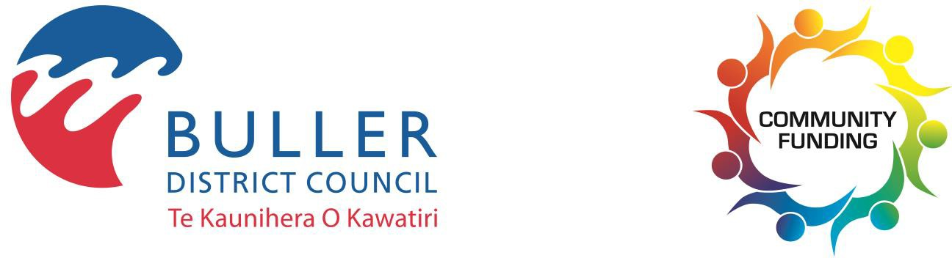

COMMUNITY LED REVITALISATION FUND APPLICATION

The Buller District Council Community-Led Revitalisation Fund (CLRF) aims to partner with and support community groups who want to work with Council to achieve the following objectives:

If you want to work with Council and enhance our district,
read the Community-Led Revitalisation Fund Information brochure
before filling out this application to ensure your project meets the criteria.

Applicant’s details

For photocopying purposes, please use a black pen to complete this form on paper. Please ensure you complete all sections with as much detail as possible.

Name of your community group:

Legal status of your community group (e.g. trust, incorporated society, club, registered charity, board, sub-committee)

Postal address:

Postcode:________________ Email:

Contact people:

Name | Position in organisation | Daytime phone number
Main contact:
Secondary contact:

When was the group established?

What are your group’s main objectives?

Community engagement
Describe how you have engaged with your community to identify the project(s) you are applying for?

Project details
About your project(s):
Summarise your project here. Attach full details of your project to your application (including scope of work, affected parties, timeline and key milestones, concept drawings and outcomes).

Community impact
How will your project(s) benefit the wider community?

Which of the following objectives will your project contribute towards?
If your project does not support an objective insert N/A.
Yes/No/N/A | Objectives
 | Transform our public spaces.
 | Bring new life to our communities and enhance community wellbeing.
 | Grow community ownership of our places through the contribution of volunteers.
 | Strengthen the relationship between Council and the community.

Does this project take place on Council owned or leased land?
Does this project enhance any master design plan that exists for that area?
If yes which one. Copies of master design plans can be downloaded from Council’s website or contact Community Services staff for more information.
Future maintenance
Do you intend to manage the project once it is complete? Or do you wish Council to take over the maintenance and ongoing management of the project?

How do you see future maintenance of the project occurring?

Will your project require a building and/or resource consent? If you are unsure, please get in touch with Council to determine if any consents will be required. Please be aware it may be your responsibility to obtain relevant consents.

Estimated project costs
Please provide details about how you will spend any funding you receive. Invoices for goods or services purchased for the project need to be addressed and sent to the Buller District Council. The Buller District Council will pay the invoice/s on your behalf. Any unused funds will remain with Council so that they can be used for other projects in the district.
Quotes are helpful to include with your application and will aid Council in making funding decisions.
Item/activity/project | Detail – what will you be purchasing? | Cost ($) | Plus GST  (if any)
Total project cost: |  | $

If you are seeking funding from other sources please outline these below.

From | Applied/Received/Other | Amount ($)
Total other funding

How much funding are you applying for?
Total project cost
Less total other funding
Amount you are requesting from this Revitalisation Fund

Have you received funding from the Community Led Revitalisation Fund in the past?
(If yes please complete the table below for your most recent project.)

Year | Project | $ Amount | Was your project completed? If not feel free to write an explanation.

Community Outcomes

Which of the Buller District Council’s Community Outcomes will your project contribute towards?
If your project does not support a Community Outcome insert NA. Copies of the Community Outcomes can be downloaded from Council’s website or contact Community Services staff for more information.

Social
Our communities are vibrant, healthy, safe and inclusive.
Affordability
Our communities are supported by quality infrastructure, facilities and services that are efficient, fit-for-purpose, affordable and met our current and future needs.
Prosperity
Our district is supported by quality technology and an innovative and diverse economy that creates opportunities for self-sufficiency, sustainable growth and employment
Culture
Our lifestyle is treasured, our strong community spirit is nurtured, and our inclusive and caring communities understand our whakapapa and heritage and support lifelong learning
Environment
Our distinctive environment and natural resources are healthy and valued.

APPLICATION CHECKLIST
Information for applicants:
- Complete one application form per project.
- Applications are evaluated by the Community Grants Committee.
- Council's Community Services Officer is available if you require assistance, phone (03) 788 9683 or email grants@bdc.govt.nz
- Ensure you attach all the required supporting documents.
- The Community Outcomes can be downloaded from Council’s website.
- Failure to include all relevant information may delay the processing of your application.
- If you are unsure of the closing date, please contact Customer Services. Late applications will not be accepted.
- Please keep a copy of the application for your records and reporting purposes.
- This document will be available to the public as part of the meeting agenda. Please refer to www.bullerdc.govt.nz/privacy or contact Council for a copy of Council’s Privacy Statement.

Checklist for your project:
- My project takes place in the Buller District.
- I have contacted Council’s Communications and Community Services Officer to discuss my application if necessary.
- I have determined whether my project requires any building and/or resource consents
- I have answered all the questions in the application form.
- I have provided estimates of project costs.
- I have provided an expected timeline which includes key milestones and completion dates for the delivery of the project.
Checklist for submitting your application:
- Filled out and signed application form. Please ensure that you have completed ALL sections of the application. If information is not provided, it may delay your application.
- Two letters of community support for your organisation, signed, dated and less than six-months old, from people not involved or connected in any way with the running of your organisation.
- You have provided full details of your project(s) with site plans, work timelines, estimated budgets, and any other project related information that will identify your project and vision if applicable.
- I/we have read and signed the declaration.

Declaration:

I/we hereby declare the information supplied in this application is correct. If the application is successful, I/we agree to provide progress and completion reports as required to Buller District Council.

I/we agree to participate in any funding audit of our organisation conducted by Buller District Council.

I/we also consent to Buller District Council collecting, retaining and using the contact details of our organisation that have been listed in this application.

I/we confirm we have the authority to provide these details and to commit the organisation to this application.

Where funds are approved, I/we agree to acknowledge Buller District Council in all promotions carried out.

Name | Signature
Main contact:
Secondary contact:

Send your completed application to: Buller District Council, PO Box 21, Westport 7866
or email to grants@bdc.govt.nz
The personal information that you provide in this form will be held and protected by Buller District Council in accordance with our privacy policy (available at bullerdc.govt.nz/privacy and at council libraries and service centres) and with the Privacy Act 2020. Council's privacy policy explains how we may use and share your personal information in relation to any interaction you have with the council, and how you can access and correct that information. We recommend you familiarise yourself with this policy.

